# 1.action

## 1.得到上传文件的名称（由Struts 2 规定的）imageFileName(上传文件+FileName)

**public** **class** HelloWorldAction {

**private** File image;

**private** String imageFileName;

**public** String getImageFileName() {

**return** imageFileName;

}

**public** **void** setImageFileName(String imageFileName) {

**this**.imageFileName = imageFileName;

}

**public** File getImage() {

**return** image;

}

**public** **void** setImage(File image) {

**this**.image = image;

}

**public** String addUI(){

**return** "success";

}

**public** String execute() **throws** Exception{

String realpath = ServletActionContext.*getServletContext*().getRealPath("/images");

System.*out*.println(realpath);

**if**(image!=**null**){

File savefile = **new** File(**new** File(realpath), imageFileName);

System.*out*.println(savefile.getParentFile()+"*******是一个路径**************");

**if**(!savefile.getParentFile().exists()) savefile.getParentFile().mkdirs();

FileUtils.*copyFile*(image, savefile);

ActionContext.*getContext*().put("message", "上传成功");

}

**return** "success";

}

}

## 2.html

<!-- 上传下载 -->

<form action=*"*${pageContext.request.contextPath}*/control/department/list_execute.action"* enctype=*"multipart/form-data"* method=*"post"*>

文件:<input type=*"file"* name=*"image"*>

<input type=*"submit"* value=*"上传"*/>

</form>

## 3.然后我们设定Struts中的

<!-- 文件上传 -->

<package name=*"department"* namespace=*"/control/department"* extends=*"struts-default"*>

<action name=*"list_*"* class=*"cn.itcast.action.HelloWorldAction"* method=*"{1}"*>

<result name=*"success"*>/WEB-INF/page/message.jsp</result>

</action>

</package>

## 4.测试成功

<http://healerjean:8080/struts2/employeeAdd.jsp>

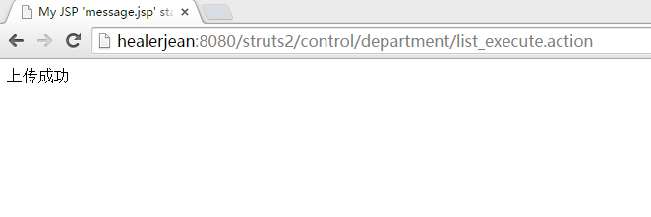

# 2.限制

## 1.得到文件的类型

**private** String imageContentType;

**public** String getImageContentType() {

**return** imageContentType;

}

**public** **void** setImageContentType(String imageContentType) {

**this**.imageContentType = imageContentType;

}

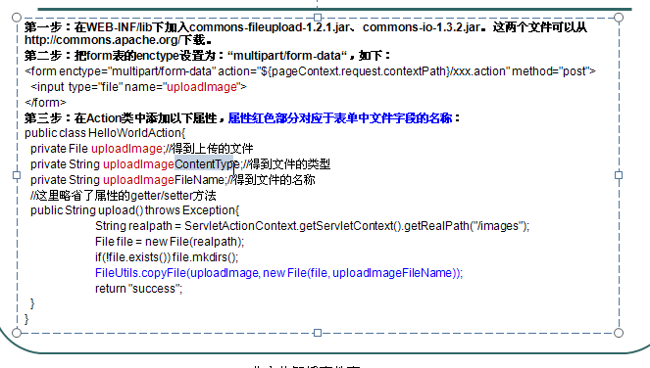

## 2.文件上传大小的限制

<constant name=*"struts.multipart.maxSize"* value=*"10701096"*/>

# 3.多文件上传

## 1.html

<!-- 多文件上传 -->

<form action=*"*${pageContext.request.contextPath}*/control/department/list_execute.action"* enctype=*"multipart/form-data"* method=*"post"*>

文件1:<input type=*"file"* name=*"image"*><br/>

文件2:<input type=*"file"* name=*"image"*><br/>

文件3:<input type=*"file"* name=*"image"*><br/>

<input type=*"submit"* value=*"上传"*/>

</form>

## 2.action 使用数组就可以

**public** **class** HelloWorldAction {

**private** File[] image;

**private** String[] imageFileName;

**public** File[] getImage() {

**return** image;

}

**public** **void** setImage(File[] image) {

**this**.image = image;

}

**public** String[] getImageFileName() {

**return** imageFileName;

}

**public** **void** setImageFileName(String[] imageFileName) {

**this**.imageFileName = imageFileName;

}

**public** String addUI(){

**return** "success";

}

**public** String execute() **throws** Exception{

String realpath = ServletActionContext.*getServletContext*().getRealPath("/images");

System.*out*.println(realpath);

**if**(image!=**null**){

File savedir = **new** File(realpath);

**if**(!savedir.exists()) savedir.mkdirs();

**for**(**int** i = 0 ; i<image.length ; i++){

File savefile = **new** File(savedir, imageFileName[i]);

FileUtils.*copyFile*(image[i], savefile);

}

ActionContext.*getContext*().put("message", "上传成功");

}

**return** "success";

}

}

.